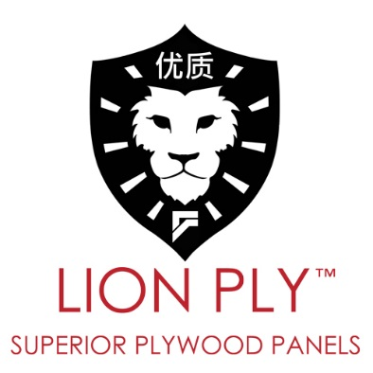

Revision Date: 28-June-2018

LIONPLY - PRODUCT SPECIFICATIONS

PRODUCT: LIONPLY™ ROTARY CUT BIRCH PLYWOOD PANELS
SPECIES: BIRCH FACE & BACK
CORE SPECIES: FULL POPLAR CORE
CONSTRUCTION: VENEER CORE
FINISH: UV CURED 100% SOLID COATING
GLUE TYPE: E0 emission
PANEL MEETS: ULEF, CARB 2, TSCA VI
FORMALDEHYDE EMISSION: 0.01ppm
FLAME SPREAD CLASS: B
ASTM E84 Flame Spread Index: 55
ASTM E84 Smoke Developed index: 85
COUNTRY OF ORIGIN: CHINA

FIRE RATING CLASSIFICATION

1. 2006 International Building Code
a. Section 803 Wall and Ceiling Finishes, Paragraph 803.1 General states, “Interior wall and ceiling finishes shall be classified in accordance with ASTM E- 84.Such interior finish materials shall be grouped in the following classes in accordance with their flame spread and smoke-developed indexes.
i. Class A: Flame Spread 0-25; smoke-developed 0-450
ii. Class B: Flame Spread 26-75; smoke-developed 0-450
iii. Class C: Flame Spread 76-200; smoke-developed 0-450
Class A,B, and C correspond to type I, II, and III respectively in other codes such as SBCCI, BOCA, ICBO.
They do not preclude a material being otherwise classified by the authority of jurisdiction.
______________________________________________________________________________

Specifications Continued,
FORMALDEHYDE TEST DATA

We confirm that our Lionply™ plywood meets: CARB & TSCA VI
Lionply™ EO emission panels tested using ASTM D6007-14, Standard Formaldehyde Emission from Composite Wood Products and Quality Assurance Requirement for Manufacturer of Composite Wood Products.

Referencing Report No.: 103514284GRR-001bRR
Date: 21-May-2018 P.O.: CAN20-0000210341 Revision Date: 24-May-2018

